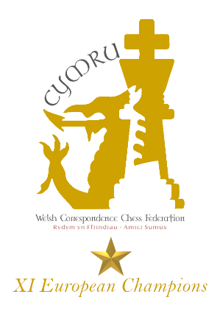

Welsh Correspondence Chess Federation
  - ICCF Congress 2024 Chess Events
Chess players from North Wales and Cheshire are warmly invited to participate in two free chess events to be held during the ICCF Congress, at the Imperial Hotel, Llandudno, on Tuesday 13th August and Wednesday 14th August.
ICCF Congress is an annual meeting of delegates and officials of the International Correspondence Chess Federation. 2024 will be the third time Congress has been held in Wales since 2015. As part of the social programme, it is traditional to organise two over the board chess events for ICCF delegates, officials, and local players to participate in.

Blitz Tournament, Tuesday 13th August 2024, 20:00
This will be a rapid play Swiss event, with a time control of five minutes plus a three second increment.

Match vs ICCF, Wednesday 14th August 2024, 20:00
An international team of correspondence chess players (including CC Grand Masters and World Champions) will take on a team of local players from North Wales and Cheshire – do you think correspondence chess players can play without their engines?... this is your chance to find out!

More Information about Correspondence Chess
We don’t play by postcard anymore; all our moves are sent though the ICCF website. Wales recently won the 11th European Team Championship in correspondence chess!
If you are interested in joining the Welsh Correspondence Chess Federation and representing Wales in international correspondence chess events, please contact Russell Sherwood leanthinker@hotmail.co.uk
Our website is https://welshccf.org.uk/
For English players, please contact Phill Beckett phillipbeckett@yahoo.com

Entries
To enter either or both events, please send the following information by email to congress@welshccf.org.uk

Name:
Club (if applicable):
WCU Rating (if applicable):
ECF Rating (if applicable):
FIDE Rating (if applicable):
I would like to participate in the blitz tournament on Tuesday 13th August: Yes/No
I would like to participate in the chess match against ICCF on Wednesday 14th August: Yes/No

The venue for both events will be the Imperial Hotel, The Promenade, Vaughan Street, Llandudno LL30 1AP.
If you register and are unable to participate, please email us to cancel.

