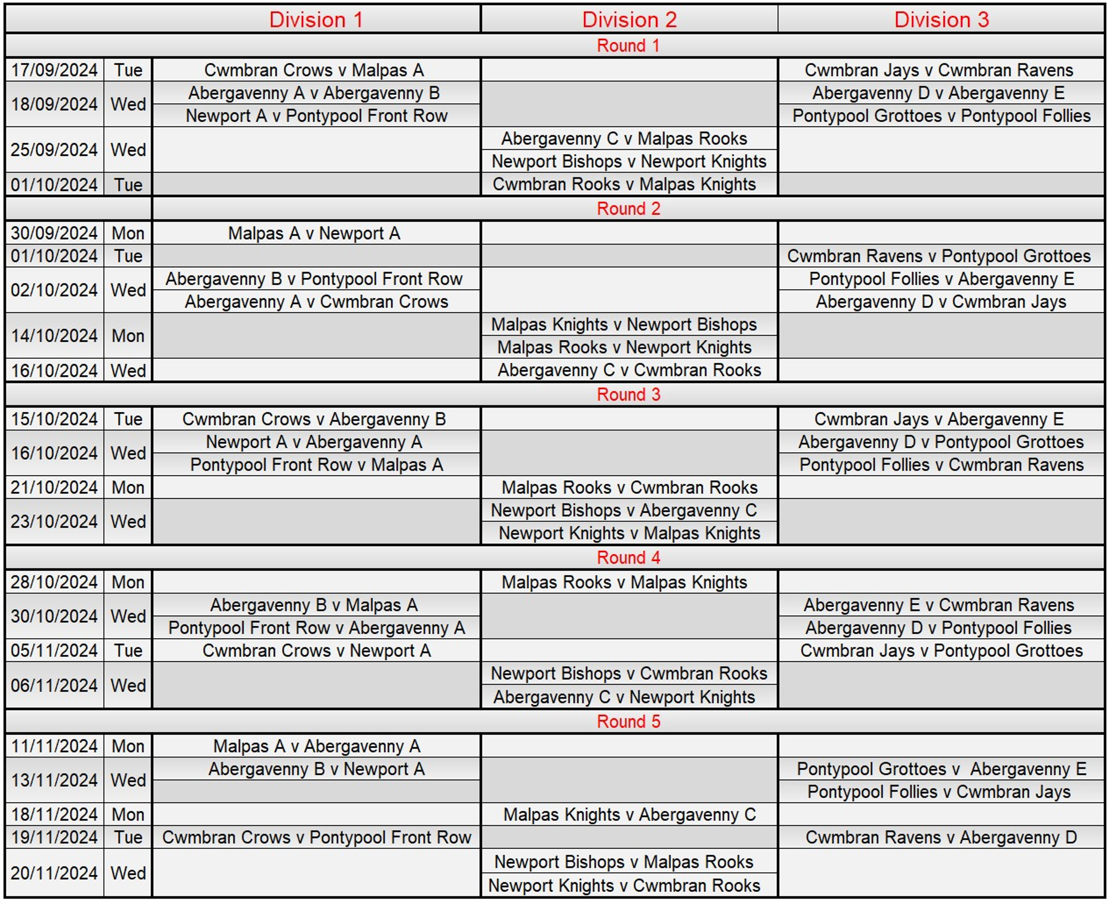

Notes:
- The first named team is at home
- Players cannot play for more than 1 team in the same round.
- Players over 1600 who play in division 2 cannot play for more than 1 team in that division.
Mark Adams.
GCA League Controller. chess@mark-adams-home.com

